Spring 2025
Cse-5392 wireless Communications
the university of texas at arlington


lab 5 report
Submitted toward the partial completion of the requirements for CSE 5392
Under the guidance of
Prof. Jason Losh
By:
Dario Ugalde, 1001268068

Introduction
This lab provided a practical opportunity to test the quality of transmitting signals over various antenna types as well as the impact of placing obstacles between a transmit and receive antenna. The antennas used for this lab included a total of three antennas. Two were manufactured antennas: a 2.4GHz Yagi Uda and an 8.0GHz X-band horn. The final antenna was the 725MHz folded dipole antenna we created in lab four. For each of these antennas, we tested the effects of glass and the wooden door in the lab. The following sections of the report document our findings.

Steps 1 – 10: Configure Various Antennas
To comply with federal regulations, we began the lab by selecting safe transmit frequencies for each of the antennas and calculating the legal transmission limits of each one. The calculations for each of these are described in the following sections.

Yagi Uda
The following tables document the configurations calculated by our team to safely use the Yagi Uda antenna:

Power (dBm) | -46.25
Distance (m) | 3
Gain (dBi) | 25
Figure 1. Yagi Uda antenna variables used for safe transmission levels

Power (W) | 2.3714E-08
Area (m^2) | 113.10
PD (W/(m^2)) | 2.097E-10
R (ohms) | 377
Antenna Gain | 316.23
Max Power Density and E-Field Strength
PD (dBm/(m^2)) | -41.78
FS (uV/m) | 5000
Figure 2. Transmission level calculations based on the variables from Figure 1
Using FCC Bulletin OET63, we found that 5,000 μV/m is the safe periodic transmission level. By using the provided Field Strength Calculator from class we found our variables that yielded the desired field strength for this antenna. Once verified by the TA, we were able to start collecting data regarding the obstacles and their impact on the signal’s power as received by the PCB antenna. Those measurements will be detailed in the following section

X-band Horn
The same process was followed once again for the X-band horn. Our calculations are shown below:

Power (dBm) | -41.25
Distance (m) | 3
Gain (dBi) | 20
Figure 3. X-band horn antenna variables used for safe transmission levels

Power (W) | 7.49894E-08
Area (m^2) | 113.10
PD (W/(m^2)) | 6.631E-10
R (ohms) | 377
Antenna Gain | 100.00
Max Power Density and E-Field Strength
PD (dBm/(m^2)) | -41.78
FS (uV/m) | 5000
Figure 4. Transmission level calculations based on X-band horn variables from Figure 3

Folded Dipole
This process to calculate the field strength for our folded dipole was completed as part of lab four and are provided once again for convenience below:

Power (dBm) | -23.35
Distance (m) | 3
Gain (dBi) | 2.1
Figure 5. Folded dipole antenna variables used for safe transmission levels

Power (W) | 4.62E-06
Area (m^2) | 113.1
PD (W/(m^2)) | 4.09E-08
R (ohms) | 377
Antenna Gain | 1.62
Max Power Density and E-Field Strength
PD (dBm/(m^2)) | -41.78
FS (uV/m) | 5000
Figure 6. Transmission level calculations based on folded dipole variables from Figure 5

Step 11: Measure Effects of Obstacles on Power
With the FCC regulations safe transmission levels determined for each of our antennas, we could proceed to begin transmitting and determine the effects of various obstacles on our antenna transmissions. The following sections document our measurements for each antenna type:

Yagi Uda
To properly document the power of the transmission signals sent to the antenna, we had to determine the loss from the coax cable leading up to the antenna. We used a brown 6 in. coax and a UtiFlex coax in series to reach the antenna from the signal generator. This configuration was determined to have a loss of -6.4 dBm at 2.4GHz.
Once loss was accounted for, we began to take measurements of the transmitted signals with obstacles blocking the transmit source. The table below documents our findings:

Materials | Power (dBm)
Glass | -90
Wooden Door | -87
Wooden Block | -85
Backpack | -91
Figure 7. Power (dBm) of Yagi transmitted signal through various materials
The Yagi antenna was particularly problematic during our lab time. Being able to detect the antenna’s transmissions were at times not stronger than the ambient noise. Particularly with the glass and the backpack being placed as an obstacle. To remedy this, we tested various orientations of the PCB and Yagi antennas. The measurements above were the optimal points we could find while working through the previously mentioned issues.

X-band Horn
Like the Yagi antenna, the cable loss leading up to the antenna was calculated to be -41.5 when transmitting over 2 UtiFlex coax cables and the frequency doubler with the RF output frequency of 8.0GHz.
The following measurements were documented for the X-band horn:

Materials | Power (dBm)
Glass | -60
Wooden Door | -61
Hand | -73
Backpack | -64
Figure 8. Power (dBm) of X-band Horn transmitted signals through various materials
The X-band horn was able to maintain a mostly consistent power level through the materials. It was interesting to note, the hand being placed over the horn had the most significant impact over the signal. In class we discussed how diatomic oxygen causes a significant amount of loss for higher frequency signals. That phenomena is likely at play in this situation where humans are comprised of mostly water, causing much of the signal to be lost to the water in a human hand.

Folded Dipole
The folded dipole antenna was used as our final test case. The loss for the cabling used in this configuration was measured at 32.5 dBm with one of the brown 6 in. coax cables and the UtiFlex coax. The following table documents the measurements of the obstacles:

Material | Power (dBm)
Baseline | -39
Glass | -38
Wood | -49
Person | -67
Figure 9. Power (dBm) of folded dipole transmissions through various materials
It’s interesting to note the glass had nearly no effect on the transmitted signal with the folded dipole. The wooden door caused a fair amount of loss while having a person block the transmission caused a significant amount of loss. The reason for this may be the same as with the x-band horn where the water in a human impacts the signal.

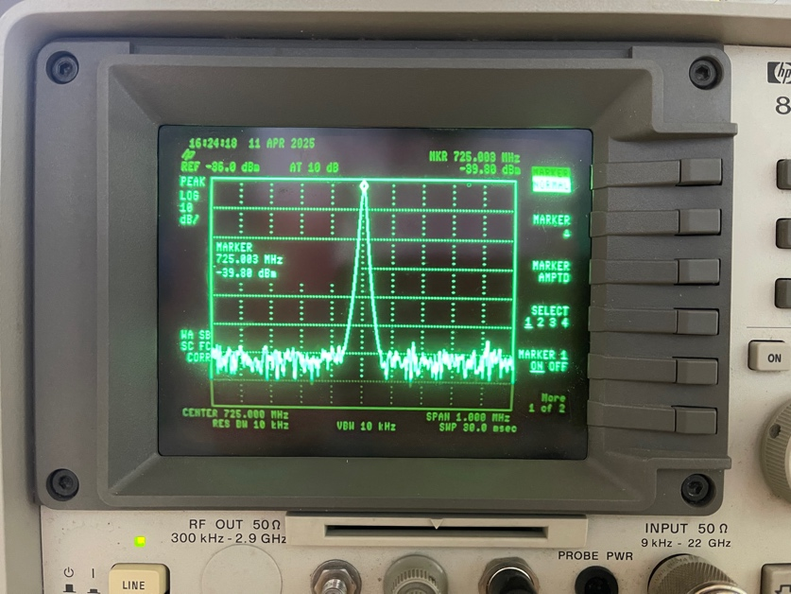
Figure 10. Baseline folded dipole antenna measurement from the spectrum analyzer

Step 12: Off-Angle Variations in X-Band Horn Transmission
The last part of the lab involved rotating one of the x-band horn antennas to understand how the horns produce a directional-based field as opposed to other antenna types that produce a field around the source. The measurements are documented in the table below:

Angle (degrees) | Power (dBm)
5 | -61
10 | -65
15 | -71
20 | -73
Figure 11. Effect on received power as X-band horn is rotated
The figure above demonstrates how the direction of an x-band receive horn not being aligned with the transmit horn can significantly reduce the received transmission. As the angle of error increased the received power dropped, with a 15-degree difference resulting in a -10 dBm drop.

Conclusion
This lab provided practical experience with working with three different antenna types and allowed us to understand how we might want to use them. For example, an X-band horn would be good to use in scenarios where a line-of-sight transmission is expected to guarantee the signal is transmitted most effectively to its intended recipient. Another takeaway from the lab was the example of the human body causing significant amounts of transmission loss to a signal due to the water content of humans. These insights will be good to carry forward in the event of working with RF systems over the course of our careers. Images of the antennas as used in the lab are included below for convenience.

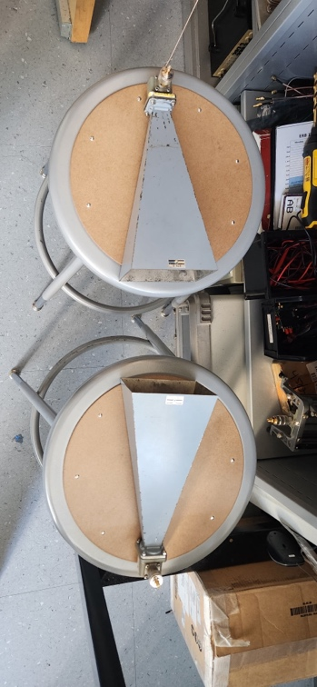
Figure 12. X-band horn antennas used for lab 5

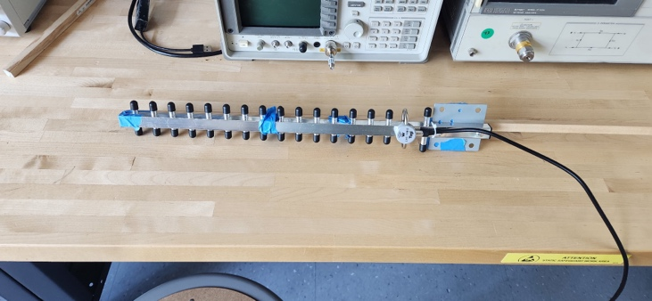
Figure 13. Yagi Uda antenna used for lab 5

